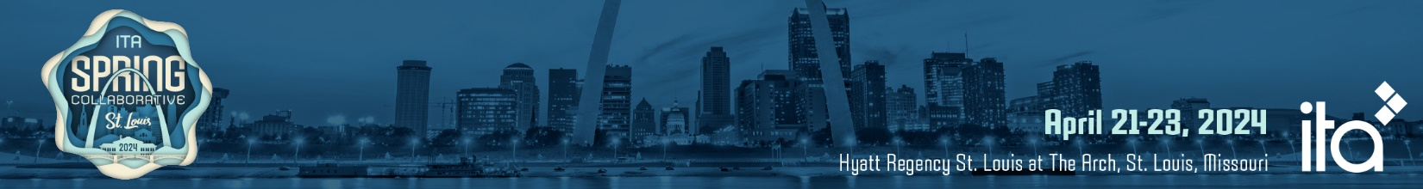
Keynotes & Deep-Dive Workshops
Keynotes
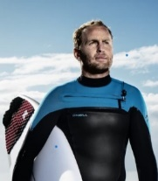 | Sunday – 4:45 – 6:00 PM  Life Beyond Fear  Mark Matthew  Professional ‘Big Wave’ Surfer and Red Bull Athlete

Through his career as a professional ‘Big Wave’ surfer and Red Bull Athlete, Mark Matthews has become obsessed with the relationship between personal growth, high performance and fulfilment. This Life Beyond Fear keynote Mark takes the audience through deconstructed, fine-tuned, and personalized emotion and resilience techniques that help successfully strengthen one’s mindset and sustain long term performance.

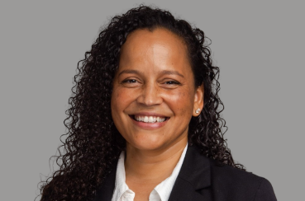 | Monday – 8:30-9:30 AM  The Landscape of AI Innovation  Noelle Russell  Multi Year-Award Winner in AI for Companies: Microsoft, IBM, NPR and More
An overview of current trends and the importance of Inclusive innovation. In this session, renowned AI leader Noelle Russell takes a look at how specific industries are evolving due to the implementation of generative and applied AI technologies. As Russell gets groups thinking about AI and how it can be leveraged in support of their business goals, she shares real-life case study applications that demonstrate more than a dozen applied AI models that can be leveraged to optimize business, create game-changing solutions, and power growth. As Russell examines the opportunities that AI presents for organizations, she also considers the risks, challenges, and ethical considerations — focusing in depth on how AI can be implemented to support human ingenuity, rather than replace it. If your organization is looking to successfully expedite innovation and improve the accessibility of its applications, this program is the perfect starting point.
Deep-Dive Workshops – Monday, 10:00 AM – 3:15 PM
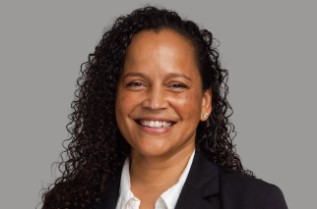 | Workshop 1  The Future of AI In Your Industry  Noelle Russell  Multi Year-Award Winner in AI for Companies: Microsoft, IBM,  NPR and More
In this session, renowned AI leader Noelle Russell takes a look at how specific industries are evolving due to the implementation of generative and applied AI technologies. As Russell gets groups thinking about AI and how it can be leveraged in support of their business goals, she shares real-life case study applications that demonstrate more than a dozen applied AI models that can be leveraged to optimize business, create game-changing solutions, and power growth. As Russell examines the opportunities that AI presents for organizations, she also considers the risks, challenges, and ethical considerations — focusing in depth on how AI can be implemented to support human ingenuity, rather than replace it. If your organization is looking to successfully expedite innovation and improve the accessibility of its applications, this program is the perfect starting point.
Topics to include:
• Ethical Foundations in AI
• Scaling Inclusive AI
• Design Thinking for AI
• Envisioning the Future

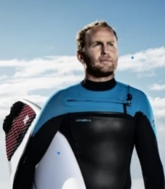 | Workshop 2  The Next Wave  Mark Matthew  Professional ‘Big Wave’ Surfer and Red Bull Athlete

The Next Wave is a video-based choose-your-own-adventure teaming session that follows the exciting career of professional big-wave Surfer, Mark Matthew and his team.

In the ocean, you must stay hypersensitive to change, continually reassessing conditions and refocusing goals and strategies. This creates a great environment to explore team dynamics, leadership, communication, and the values that underpin your company’s success.

The audience is grouped into professional surf teams, including the roles of photographer, swell forecaster, water safety crew, manager, publicist, and surfer. You’ll be transported out into the ocean (virtually) where you will face a series of exciting scenarios, have to make difficult decisions, and either reap the rewards or face the consequences of those decisions.

After a brief immersion into the business of Big Wave Surfing, you and your team will take the reins of Mark’s career. You’ll be faced with a series of real-life scenarios from Mark’s career. Each scenario will leave you with two options. As a team, you will make your decision, watch the outcomes, and then get your results.

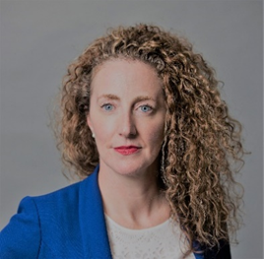 | Workshop 3  Negotiation & Conflict Types: Engagement Tactics Plus Negotiation Excellence: How To Make Better Decisions Through Negotiation Skills  Joanna Shea  CEO and Co-Founder of the Negotiations Collective
The first part of the Workshop will be on Negotiation & Conflict Types and Engagement Tactics. Skilled negotiators know their natural negotiation and conflict style, can identify their counterparts, and can adjust their own to mirror, soften, or push their counterparts for the best results. In this two-hour session, the NC will train attendees in:
• Identification of one’s natural negotiation and conflict type
• How to identify a counterpart's natural negotiation and conflict type
• The pros and cons to each type
• When to deploy each type
• The results each type will likely achieve
• Techniques required to get the best out of each type
• Engagement tactics used by skilled negotiators, and how to react in kind
The second part will be on Negotiation Excellence: How to make better decisions through negotiation skills. No two negotiations are the same. Political (internal or external), economic, cultural, environmental, personal and or a variety of other factors will present themselves in diverse ways in different negotiations. You cannot control these variables, no matter how talented a negotiator you are. This second two-hour session will deliver training on how to prepare, push your value proposition, how you present yourself as a negotiator, and how you offer acceptable solutions that create more value.

Key learning points will include:
• Strategic Networking
• Value Creation
• Process
• Planning
• Teams
• Strategy

Prepare for MORE. More trust. More opportunity. More confidence. More value.

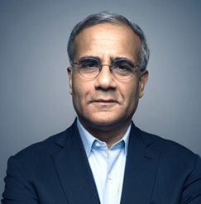 | Workshop 4  Remaining Relevant In Transformative Times: How To Manage Change, Lead The Future And Upgrade Yourself And Your Firm  Rishad Tobaccowala  Author, Speaker, Teacher and Advisor For Four Decades

In this session, Rishad will lead an interactive workshop playing built around understanding the four big shifts impacting every business, discuss how to apply the six keys to unlocking change. We will then discuss how best to lead on a world of debossification and how we all can continue to upgrade our mental operating systems.
Rishad’s best-selling book “Restoring the Soul of Business: Staying Human in the Age of Data” was published globally by HarperCollins and focusses on helping people think, feel, and see differently about how to grow their companies, their teams and themselves in transformative times.
Tobaccowala was named by BusinessWeek as one of the top business leaders for his pioneering innovation and TIME magazine dubbed him one of five “Marketing Innovators. He is the Ad Age Interactive Hall of Fame and has received a lifetime achievement silver medal award from the Chicago Ad Federation, an Inspire Award for motivating and building talent from the Advertising Education Foundation and the Association of National Advertisers and was named an Advertising Legend by the Advertising Club of New York. Rishad is also chairman of The Tobaccowala Foundation, which helps over 10,000 people gain better access to health and education in India.
Tobaccowala holds a bachelor’s degree in mathematics from the University of Bombay and an MBA from the Booth School of Business at the University of Chicago with which he remains closely involved.

