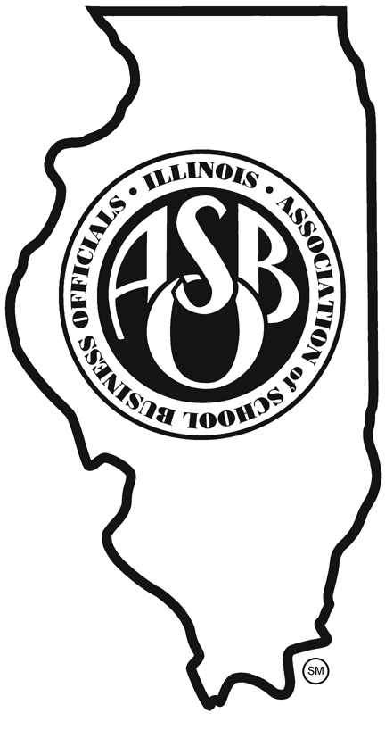

Illinois ASBO
_________________________________

New Content Recommendations

_____________________________________________________________

Gathered during the JULY 2016 PDC Meeting

- Tax Levy
- GATA Training
- Cash Management Issues
- Legislative Updates
- Creative Revenue Sources
- Expansion & Renovation of Facilities
- LTD policies
- Payroll
- Building Security & Surveillance
- State Funding Updates
- 21st Century Learning
- Staff/Board Issues
- Long Range Construction

